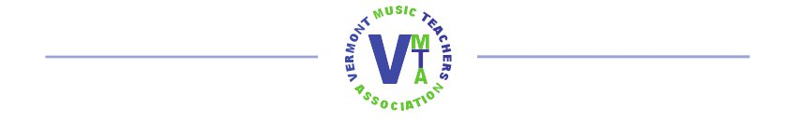
Noteflight Learn
Music Notation Software for members of VMTA and their Students
Enrollment Form

Teacher name and email:

_________________________________________________________________________

Teacher phone and best time to call:

_________________________________________________________________________

Approximate number of students in your studio who might like to participate: __________
(Students can be added or removed at any time.)

This enrollment is for July 1, 2023 – June 30, 2024.
Each enrolled teacher agrees to
- work in a constructive and respectful manner on the Noteflight Learn group website and guide students to do the same
- assist students who choose to use the online mentoring program, and abide by online guidelines for that program
- consult online tutorials or contact Sarah Williams for technical support

Signature: _______________________________________ Date: ______________

Return form to Sarah Williams at sarah5432@gmail.com
or 796 North St, Montpelier, VT 05602 (802-223-5307)

